**CREATE A NEW CLIENT IN JDE**

**BENELUX – PLANT 90202 / COMPANY 00090**

(El procediment és el mateix que per França, d’on està copiat)

**IMPORTANT**

Always validate customer VAT

<https://ec.europa.eu/taxation_customs/vies/?locale=en>

**\*\*\*\* Please, make sure that the new client is not already existing in JDE**

**\*\* Sales/Customer and prices/Address Book**

1. **Click “+” to create a new customer:**

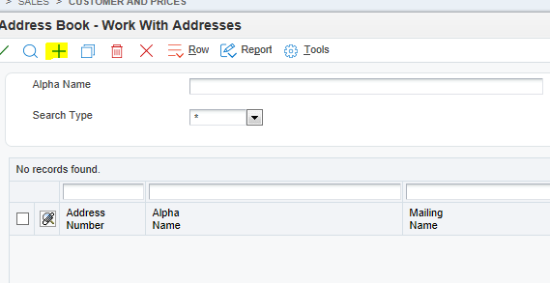

MAILING 🡪 RAÓ SOCIAL

ADDRESS BOOK 🡪 NOM COMERCIAL

1. Fill in fields **Alpha Name (Customer Name**) + **Tax ID**, **Search Type** & **Business Unit**:

**Alpha Name:** Comercial name

**Search Type:**

C🡪 invoicing customer

D🡪 Shipping customer

V – Suppliers (Filial Agents)

**Business Unit:**

Benelux branch: 90202

Other customers/branches: 1

1. **Go to Mailing and fill in address of the customer:**

**Attention!! Mailing Name must contain always the type of company: BV, BN…**

*** **Address Line 4**: GLN for EDI (do not use for other reason)

1. Go to **Additional 1** and fill in corresponding fields:

* **Payables**: in the case your customer is also a supplier select Y, otherwise select N
* **AR/AP Netting:** in the case of Nettings select Y
* **Add’I Ind Tax ID:** VAT number
* **Language:** select language you want to print documents for this client
* **Select Receivables Y/N**

1. **Go to related Address:**

In the case the customer is linked to another client we always inform the upper level client. Example:

1. Creating a ship to (D address) linked to a sold to (C address). We would inform on 1st Address Number the sold to

In the case we are sending the invoice to another customer different than the sold to and ship to we will inform it on 2nd Address number

1. **Go to Cat Code 1-10**

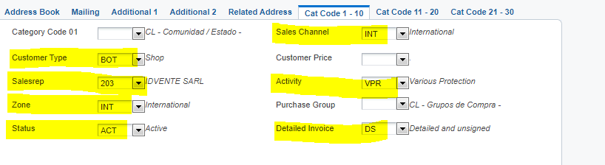

Fill in following fields:

**Category Code 01:** NL/BE/LU (el que correspongui)

**Customer Type :** BOT🡪 SHOP / AGE if it is an agent.

**Salesrep:** Representative code (If not in the list, Pilar Alvarez is the person to create them)

El contacte de Technolyt que porta el client

**Zone**: NAC 🡪 National

INT🡪 International

**Subchannel 2:**  always RET

**Sales channel:**

WEB🡪 Web

NAC🡪 National

INT🡪 International

**Activity:** Customer activity / VPR FOR AN AGENT

**Detailed Invoice:** How we would like invoices to be printed. There are few options:

* **Detailed and signed-> DF**
* **Detailed and not signed-> DS** 🡪 L’HABITUAL
* **Summarized and signed->RF**
* **Summarized and not signed->RS**

1. **GO TO CAT CODE 11-20**

* **Tarif Code Detail:** In the case you want to inform on invoice tariff code (S)
* **Subsidiary:** 000 (always)
* **Supplier Type:** EAN Deliver Note (In the case you want to show EAN code on delivery note (S))
* **Category code 14:** 00 (always)
* **Customer Discount:** In the case the customer has a fix discount. Informed on sold to (és només informatiu, no aplica cap descompte)
* **Area manager:** 05
* **Customer Service:**
* **Type of customer:** KEA (Key Account) / INA (Independent Account)

**Save customer details and Form A/R will be opened**

1. **Go to Form – A/R**

**Inform payment terms and currency:**

*Please, always confirm the bank account with Núria Roig if you have any doubts.*

**Payment Terms:** 300 (*30 DIAS FECHA FACTURA)*

**Payment instrument:** is 5 (Transfer Buff Benelux)

**Currency code:** EUR

**A/B Amount Codes:** EUR

**In the case you need to send the invoice to another address informed in related address as 2nd Address Number, on same screen on the right side inform 2 on “send invoice to” field:**

**In the case your customer has a credit, inform**

**For BENELUX branch always add 5,000.00€ to the credit limit**

**9. G/L Distribution:**

**Inform field G/L Offset:**

* **CLV1 for customers in Europe**

**Go to Tax information and inform Tax Expl Code and Tax Rate/Area:**

* **Tax Expl Code: always V**

**Tax rate:** NL21 Benelux branch – Customers in The Netherlands

NL02 Customers in Belgium and Luxemburg

1. **Go to Form – Billing Information:**

**And fill in fields in Billing Page 1:**

* **Billing Address Type:**
  + B: Bill to Address only
  + S: ship to address only
  + X: Bill to and ship to address
* **Related Address Num: 1**
* **Adjustment Schedule: depending on customers**
* BENDTO – Benelux branch
* **Customer Price Group: Always TCL**
* **Delivery instructions (mandatory field):** Sentence that will be printed on the invoice (no cal res)
* **- Cal marcar l’opció “Delivery Note”**
* **Només marcar “invoice consolidation” si aplica**

**Go to Billing Page 2 and inform details of transport if are always the same for that customer. Otherwise you will have to inform it on each order:**

* **Freight Handling Code:** Type of shipment: Express, Standard…. 🡪 013
* **Carrier Number:** Name of transport agency 🡪 10087
* **Adjustment on Invoice:** **Y** if we want to show discounts on invoice // **N** if we don’t want to show discounts on invoice
* **Route code:** Incoterm (standard (DAP)Interfaz de usuario gráfica, Aplicación

  Descripción generada automáticamente

**PRIO CODES**

One of the changes that it takes, is that all the re-works that we now were informing in the Annex of the order, have been coded and must be informed at SHIP TO level OR in the order.

That means, that for a Ship to that always has the same re-work, we will introduce the code in the customer Address Book here:

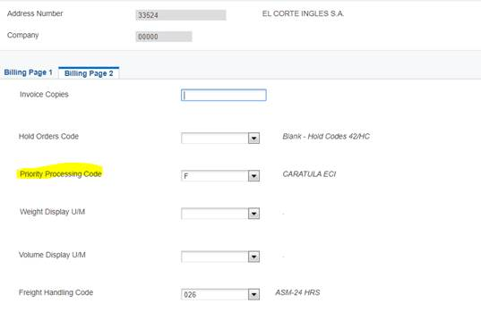

Hereafter the codes created (you can display them in JDE as usual with the magnifying glass). If you have any doubts which one to use, please do not hesitate to contact us. It is important that the code is correct because these are the instructions that the warehouse will follow to prepare the order:

0 .

A HEADER EAN

B HEADER UPC

C HEADER PRICE EUR-OB

D HEADER PRICE EUR-GMBH

E HEADER PRICE GBP

F HEADER ECI

G HEADER RUSSIA

H HEADER PRICE DTO-OB

I HEADER PRICE OUT-OB

J HEADER CLIENT

K HEADER CLIENT + BOX

L HEAD PRICE GMB + SEG + CLIENT

M HEAD PRICE GMBH + BAG + BOX

N HEADER CLIENT + BAG

O SEWED LABEL

P BAGGED

Q PACK

R BAGGED + BOX CLIENT

S HEADER EAN + BAG + BOX

T BAG CLIENT

U HEADER PRICE OB + CLIENT

V BOX MONOREFERENCE

Z ANNEX



**Click on until everything is safe.**

* **OTHER INFORMATION POSSIBLE TO ADD:**

1. **Adding attachments on customer level**

Go to address book and select the customer code. With right button select Attachments

Same as for the orders there are different attachments:

**/F** To show on invoice

**/P** To show on order confirmation

**/W** To show on work orders (Only for customize)

**/A** To show on delivery note

**/X** To show on logistics (shipment instructions)

**/** To show when entering an order

**\*\*\* If you have a different delivery address (D) for a customer, please make sure to add the JDE number as / in this attachment.**

1. **Adding information of Bank Account**

Go to Address Book and search customer code. With right button go to Bank Account

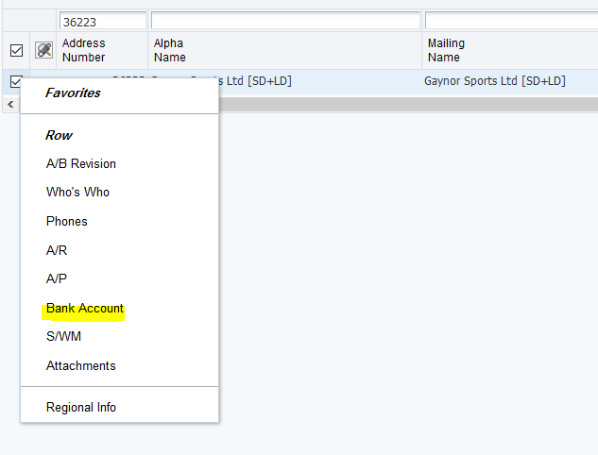

Add and fill in all information needed and safe

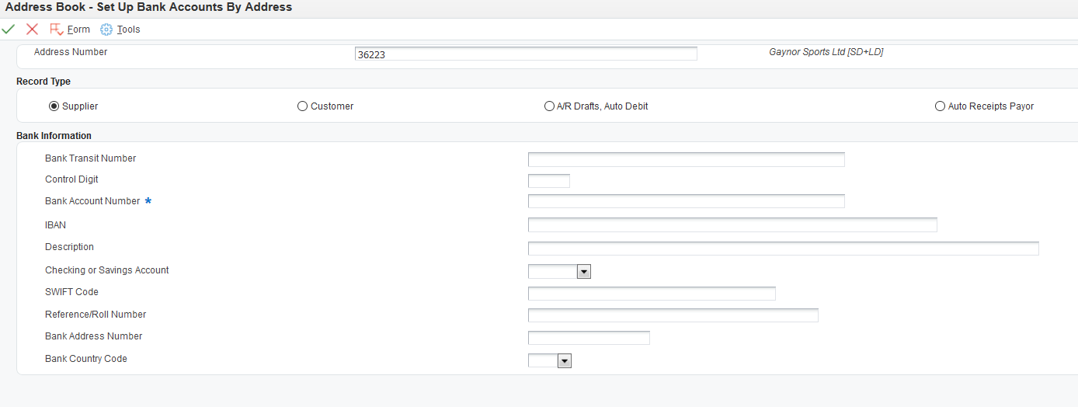

**Always in A/R Drafts, auto debit (3rd option)**

1. **Adding email addresses**

Go to Address Book and search customer code. With right button go to Who’s who

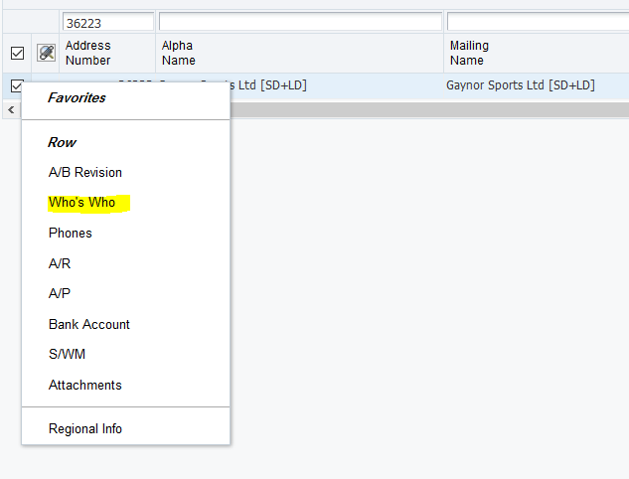

Click again on right button and go to the option you need to fill in:

1. Interfaz de usuario gráfica, Aplicación

   Descripción generada automáticamentePhones
2. Email

And just fill in fields needed for each option

Regarding email, there are different categories for them:

* + ACK: Order confirmation
  + FAC: invoice sending
  + NFC: not to send email
  + DEN: Delivery note + Packing list
  + CAR: Carrier tracking no. information (only one e-mail address) **NEW**

You are able to type more than 1 email address (except on CAR) on the same line just separating them with a “,” Example below:

[sledmores@buffuk.com,yusufj@buffuk.com](mailto:sledmores@buffuk.com,yusufj@buffuk.com)

If we need to introduce an order on the same day of creating a customer, we will need to update customer category codes. Go to Sales- Customer and prices – **Update customer category codes**:

**Data selection and submit. Introduce the customer number and**

**CAL ASSIGNAR LINIA DE NEGOCI AL CLIENT PER “ACTIVAR-LO” AL B2B (300, 303 i 403)**

Favorits / clients / activar clients B2B

Escriure el núm de client i a la columna Cd1 posar la línia que volem detallar.

**300 , 303 , 305 , 403 (standard)**

**Create new ship “SHIP TO” address:**

**Sales-Customer and prices – Address Book**

We search for the C customer and select it and copy.

Change **Search Type** C per D

**Mailing address**

**Go to related Address:**

1. In the case we create a ship to address, we inform on 1st Address Number the customer sold to

Then we will have 2 addresses for this customer



**On customer D (Ship to) go to Form – A/R**

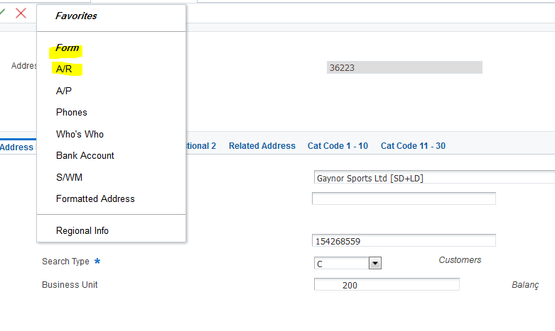

Inform all fields as the C customer

**Go to Form – Billing Information:**

And fill in fields in Billing Page 1:

* **Billing Address Type:**
  + B: Bill to Address only
  + S: ship to address only
  + X: Bill to and ship to address

Inform all the other fields as C customer (who is who, phones, etc).