CONTACTES TECHNOLYT
Dees Hetzenauer d.hetzenauer@technolyt.nl +31 621 324 135 902
Johan Wilders j.wilders@technolyt.nl +31 651 272 779 904
Silke Romain s.romain@technolyt.nl +31 621 235 223 903
Erik Hardick e.hardick@technolyt.nl +31 651 611 188 905
Paul Tijsen (CEO) p.tijsen@technolyt.nl +31 655 489 144
____________________________________________________________________________________
Dennis Klein Wilink d.kleinwillink@technolyt.nl
For a weekly sales overview reports@technolyt.com (ticket 633565)
Olaf (customized Technolyt)

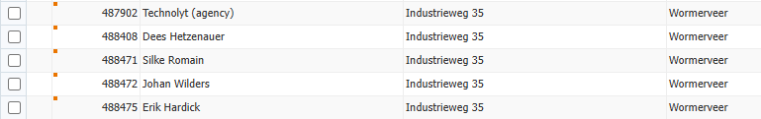

COMANDES DE: AS ADVENTURE (RETAIL CONCEPTS)
BEVER
SAFETY
Se’n ocupa la Caroline!!!!

